**EXPERIMENT 10**

**Aim:** To redesign a daily usage appliance.

**Solution:**

The appliance chosen for the analysis and conceptual redesigning is a Dish Washer.

**Short Description about Dish Washer:**

A dishwasher is a machine for cleaning [dishware](https://en.wikipedia.org/wiki/Dishware) and [cutlery](https://en.wikipedia.org/wiki/Cutlery) automatically. Unlike [manual dishwashing](https://en.wikipedia.org/wiki/Dishwashing), which relies largely on physical scrubbing to remove soiling, the mechanical dishwasher cleans by spraying hot water, typically between 45 and 75 °C (110 and 170 °F), at the dishes, with lower temperatures used for delicate items.

**General Problems Faced While using a Dish Washer**

Faulty Design Problem:

1. There should be a locking and unlocking mechanism that should be made available.
2. Pre-defined Modes for different types of utensils (Glass, metals).
3. Contemporary dishwashers can’t be stopped before the time is elapsed completely, a reset button is required.
4. Soap liquid indicator that it is less at the moment.
5. Indicator for adequate water inlet.

**Diagram showing the faulty design issues.**

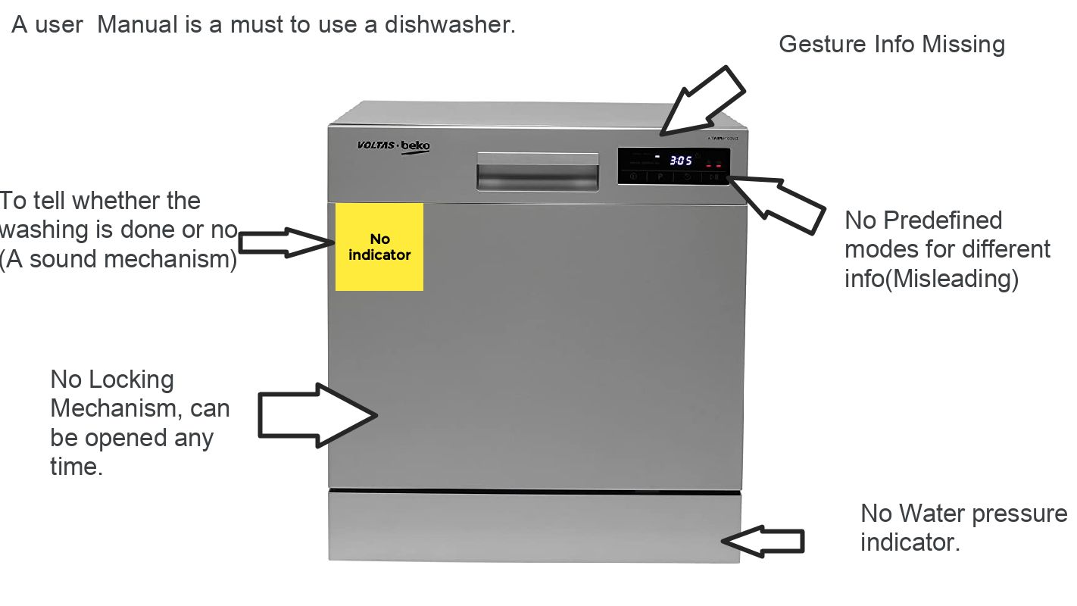

**Usability Cues Left by Previous Users**

1. A manual is a must.
2. Users need to use the dishwasher with many options.
3. While using hot water for washing if opened in middle the steam would gush out so one should avoid doing that.
4. Hot water must be used for washing glass-based utensils
5. Clean the water hose every once a while.
6. If the pressure of water is inadequate, then it takes a greater time to fill up the tank.
7. If the utensils are highly dirty repeat the wash cycle twice.

**Proposed / Conceptualized Design**

